Required information needed in all Cases
- Category, Type and Assigned to – should be reviewed to ensure in the right department
- Employee – ensure the EE information is listed
- Notify user – Should be assigned to Email/Chat team members, if it is not change to Queue, Employee Relations
- Priority – should always start with Low, unless it is an Escalated concern
  - Work stoppage – only if we can not process payroll
- Due date - Should always reflect the amount of time list under the priority.
  - NEVER let it expire. When the date expires the automatic case escalation process stops
- Division - We need to place the instance where the EE is located
  - To help team members find the EE quicker
- Subject – brief description of issue, EE and Client names and ID #, what instance the client is located
- Reported by - Employee Relations
- Attachments - Please always double check the attachments on the case since sometimes the departments attach the resolution in there without leaving notes or closing the case
  - Anytime you send an email ensure you place it in the attachments
- Subscribers - Make sure always add
  - CRM/HR
  - PAYROLL – if it involves anything to do with money
  - QUEUE, EMPLOYEE RELATIONS
    - Remove any subscribers that are no longer needed
- Internal Notes – this section is used by internal Vensure EE’s place all notes/actions/requests needed for this case. Ensure you review all notes in this section before starting to follow up
- Case Notes – this section is used from the clients to place all notes/actions/requests needed for this case. Ensure you review all notes in this section before starting to follow up
Case Follow Up
- When an associate from your region is out you are their back up to follow up on cases/chat/emails
- We should be checking the ER inbox daily for resolution emails to our cases
  - At least every ½ hour
- When you are getting ready to follow up on case ensure you sort by “Employee Relations” and sort the Create Date oldest to newest
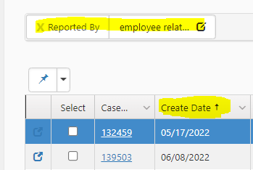
- You will review every case daily up to the current date
  - Current date cases are reviewed to see if resolution has occurred
  - We do not ask for follow up/status until 1 day after the creation date
- Make sure you fill out and reviewed all required sections of every case
- Review all attachments for resolution or next step guides
- Open the EE/Client profile in Prism
- Review Prism to ensure that the EE still needs help
- Contact who the case is assigned / department responsible for the case
  - Via Team and Internal Notes
  - If you do not hear anything after a couple of days, you can email and call
  - After 1 week escalate to your lead for next steps
  - Lead – escalate to the dept leadership the case is assigned to
    - Lead – if we do not get a response after a couple of days, we escalate to an ER Supervisor and so forth up the chain until resolved
    - THINK OUTSIDE THE BOX, use your resources
- Should be following up weekly with the EE/Client, even if we do not have a resolution
  - Ensure we are working on this and will advise as soon as we have a resolution

