Origins
Standard Operating Procedure
Client Space – Create Case
Department  Employee Relations | SOP Number
Effective Dates  1/1/2022 | Quality Review Date
Created By  Gina Delgado | Version Number  1
Purpose of the Standard Operating Procedure (SOP)

Process Workflow
Instructions | Visual Details
Open Client Space

Go to Cases > Choose a Workspace (company name)
- If the company is not listed use TEST COMPANY 12015
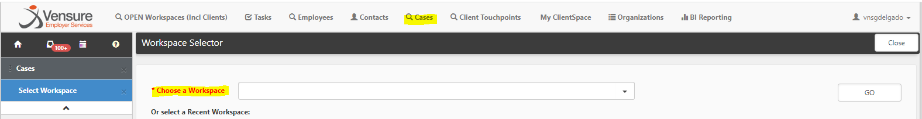
Category = select related department need to assist

Type = select the type of assistance needed

Assigned To = this section will Automatically populate
- If it needs to go to a specific person you can search for them

Employee
- Add EE, termed EE’s may not appear in search

Priority
- Low to Medium base on urgency
- High is when it is about to affect the EE paycheck, or the request has been sitting in queue awhile
- Work Stoppages is when the ability to process payroll is being affected

Make sure Disable Notifications is NOT checked

Due Date
- Should be based on your Priority selection
- Need to update the due date every time you follow up on the case, push out at least 24 hours

Subject
- Depending on the type you selected there maybe already some pre-populated information in your subject
- Enter the description of the issue / request
- Include EE and Client names and ID #, what instance the client is located

Description
- Depending on the type you selected there maybe already some pre-populated information in your description location
- Greet your team
- Put as much details as possible, ensure to include any dates, amount, names, etc.

Reported By = Employee Relations

Attachments
- delete anything that does NOT belong
- attach related form or emails regarding the issue / request

Subscribers
- add the CRM and Queue Employee Relations
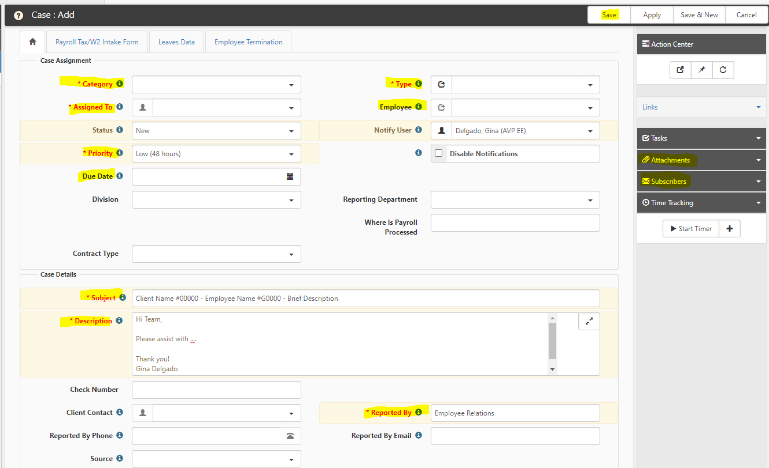

Roles and Responsibilities
Below defines any roles and responsibilities ONLY associated with the process or procedure outlined in the SOP.
Roles | Responsibilities
Technology
Reference Documents
Abbreviations and Definitions

Additional Resources
The following resources or links are to additional documentations or resources to related actions, procedures, or processes.
Document Name | Link / Location

Verification and Approval of the Standard Operating Procedure
Department Head  Gina Delgado | Date  12/14/2021
System Expert | Date

Standard Operating Procedure Change History
SOP Version: Record the new SOP version
Significant Changes: State key elements or edited sections
SOP Version | Significant Changes | Training Needed? (Y/N) | Acknowledgement Needed? (Y/N)

