Common Sail Investment Group (CSIG) Support Team
DEPARTMENT | TEAM MEMBER
Client Relations | JANTAL OSTEEN  9027 – Senior Living Capital Management (AKA Independence Village/StoryPoint)  9028 – Senior Village Management (AKA Independence Village/StoryPoint/Danbury)  9030 – Leisure Living Management  9033 – CorsoCare Staffing Agency  JAREK DEBAUCHE  9017 – Common Sail Investment Group (AKA Home Office)  9031 – O’Brien Construction  9032 – O’Brien Interiors Group  9015 – Progress At Home  9020 – CorsoCare Health Management  9022 – Valley Home Health Care  9024 – CorsoCare Hospice (AKA Laurus Hospice)  9029 – CorsoCare Pharmacy  9034 – CorsoCare Hospice of Ohio  9025 – Foodies Catering Service
Implementation | DEAN LAMPE
Payroll  (NOVAtime) | ALINA SIVETZ  (9015, 9017, 9020, 9022, 9024, 9025, 9029, 9031, 9032, 9034)  MANDY AUG  (9027)  SUE GALEWSKI  (9028)  SARAH REICHELSDORFER  (9030, 9033)
Client Solutions | ARI VORPAHL  ANTONIO RAMIREZ
Client Tax | MELISSA O’BRIEN
Workers Compensation | TERI MORGAN & empowerwcmail@vensure.com
Leave of Absence | WYKESHA GRAY
Benefits Administration | QUEUE, BENEFITS DEPT  CHARD MARTINEZ – escalation only  MADDIE BROCK – escalation only
ACA/1095/1094 | WILL DAVIDSON
Retirement/401k | DEBBIE JEANSONNE
Unemployment | QUEUE, UNEMPLOYMENT SERVICES
Workers Compensation Claims | WCNewClaims@vensure.com
Internal Human Resources  (Referrals, Sign on Bonus, Tuition) | HR@CSIG.COM
Onboarding (Non-Tech Support) | ONBOARDING@CSIG.COM
TIP / TRICKS
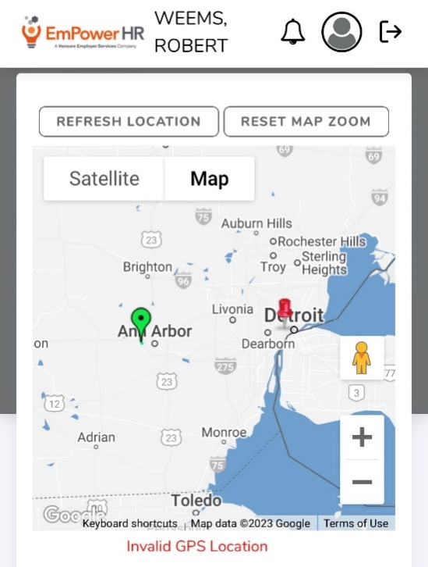
- If you have EE that is unable to clock in and are getting "INVALID GPS LOCATION" they need to REFRESH LOCATION.

- 9017 – Common Sail Investment Group (AKA Home Office)
- The only people that have access to this client are our Supervisors Maria, Geraldine, and Jhon. When you search for the WSE they will only show in Users. Advise your supervisor, they will help you assist the WSE.

- EMP uses their own Benefit providers we have their SOPs on our SP

- Use Rapid for PayCards – WSE works with client to set up any issues WSE calls Rapid directly.

- Benefit overview states the code CSIGV4 or VSP -master vision plan - the carrier is VSP.
  - They don’t provide any type of cards.
  - Employees usually go to www.VSP.com, register, and they can get all their coverage information there.
