
If an employee reaches out and asks about the Employee Perks Program, please have them perform the following steps to get them to the Employee Perks Program website:
- Direct them to their employee portal
- Have them click on “Market Place” and then “VPerks”
- Register for an account by clicking on “Start Saving”
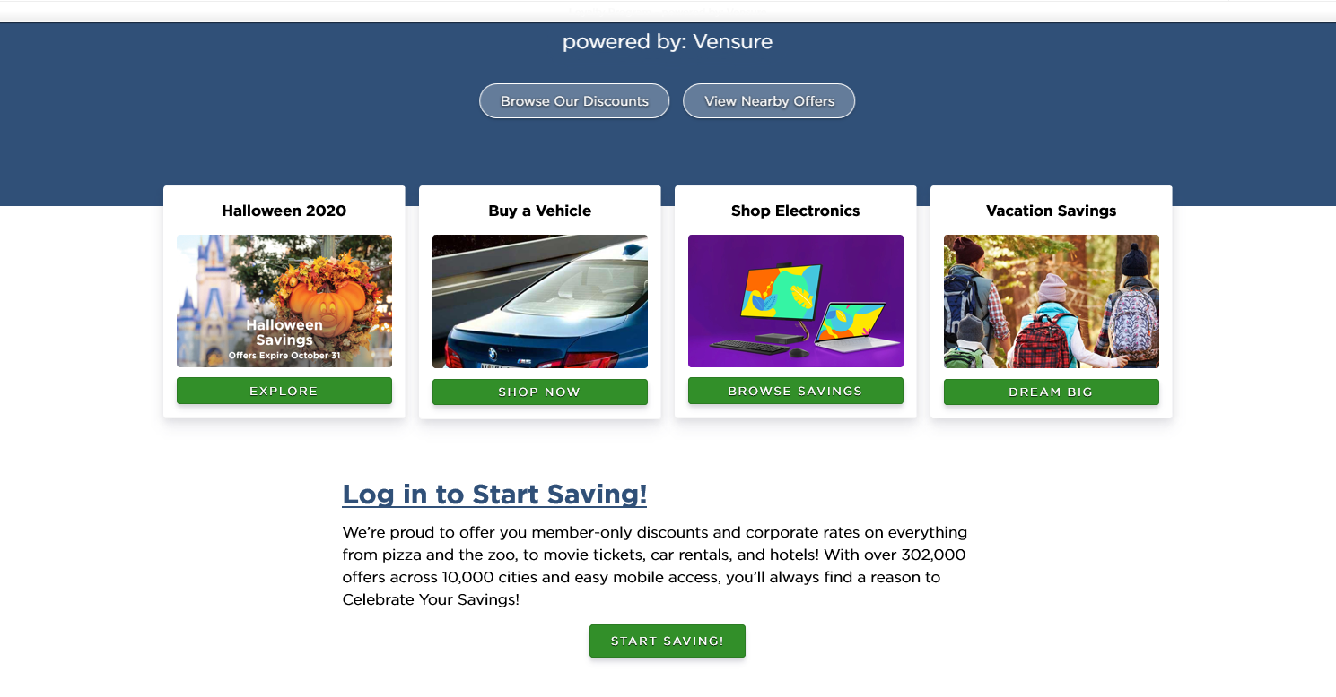
- Click on “Register”
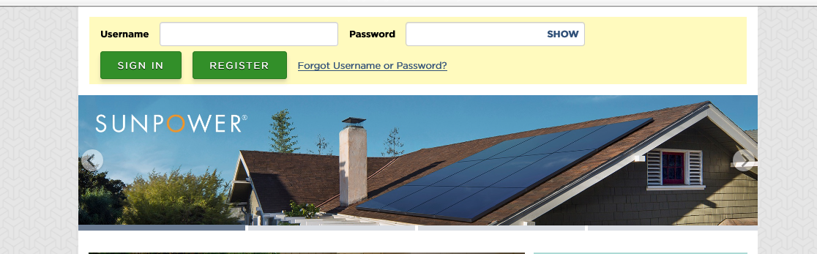
- Complete the requested information
- Click on “Submit Registration”
- Enjoy the Perks Program!

