Chat / email pratical guide

Please Access the website:
https://accounts.livechat.com/

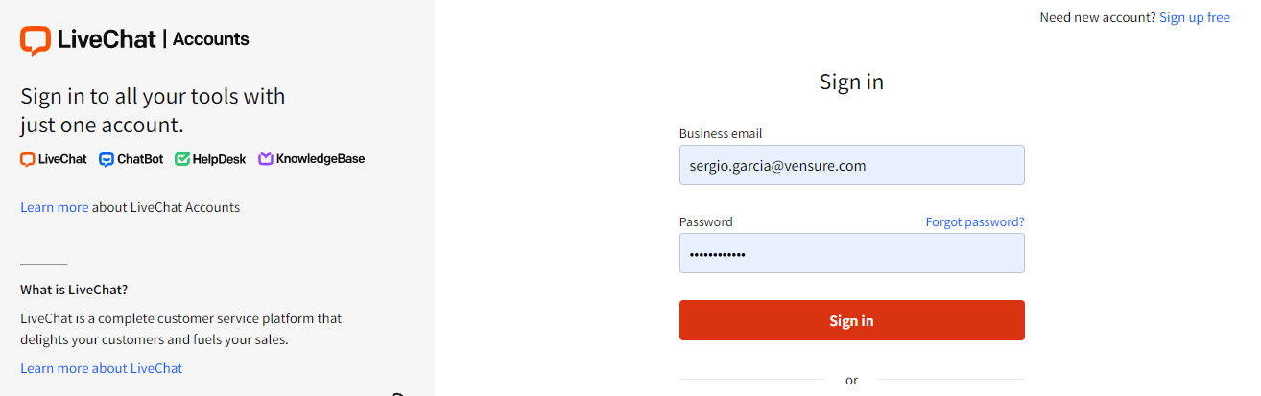
Login with the credentials you received (youremail@vensure.com) Is your username.
If you have issues when login into the system, you can open a PS ticket so Product support or Gina Delgado can assist /
Once you login…

Upon login you will see the home screen and the options that we will be using the most:
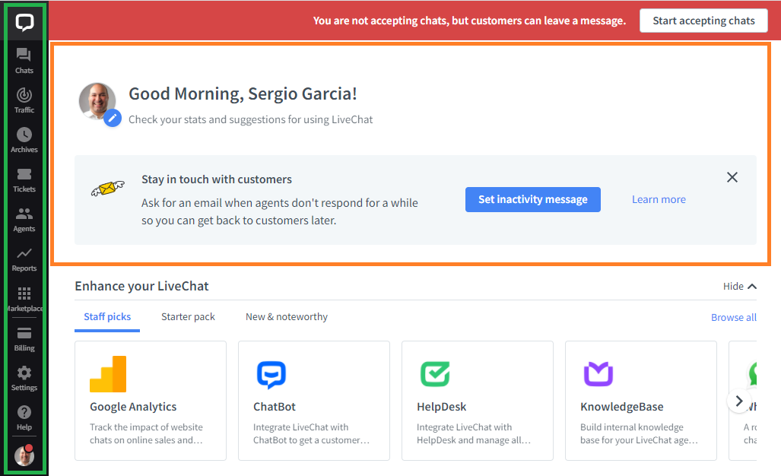
Let’s look at the features we will be using…
1. Chats
Is the place where all chats in queue will be located, is the same dynamics as If we have a queue for calls.
Note: Chats are not assigned automatically to associates, there for each associate must grab the chat and begin assisting. We have around 1 max minute to grab the chat when the associate is available.
To grab it, click on : 
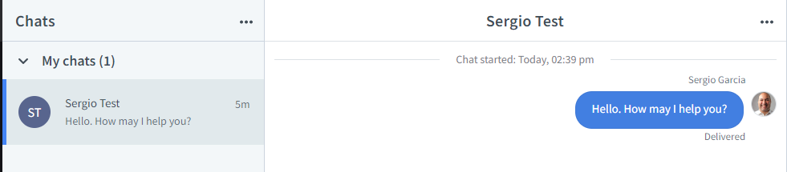
A welcome message will be sent to the employee automatically offering assistance.

Once you are into the chats module, we will see three different sections:
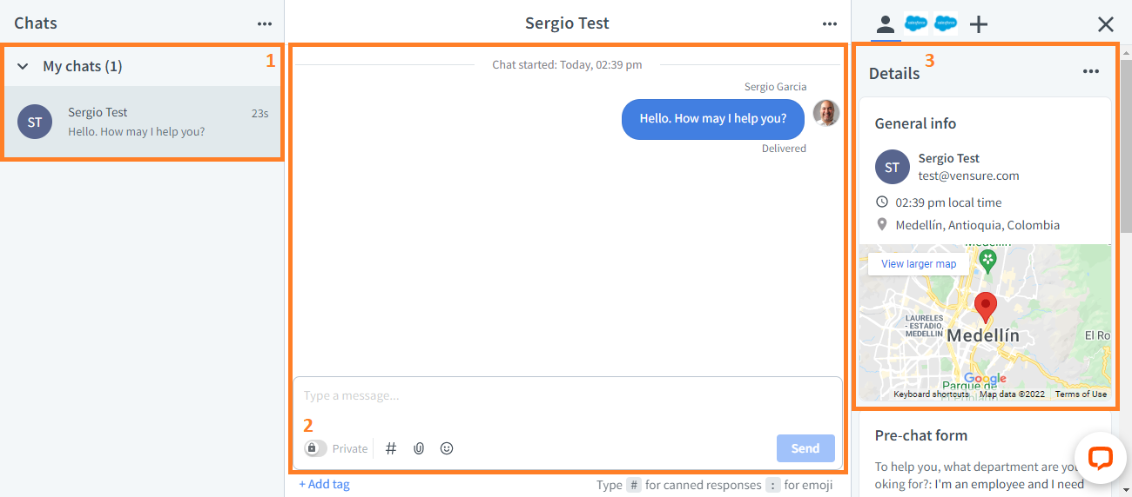

  - My Chats
In this area you will have the records of the chats you grabbed and that you are assisting with.
Is useful to keep track of conversations or request that are pending for resolution or just simply a nice place to come back and retrieve information from a chat.

Once you finish with the chat and there is no need for further action, please close the chat and archive it, the system will display who closed the chat if it was the associate or the employee.

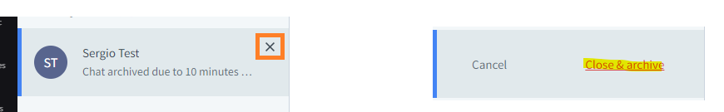

  - Chat Window
This is the place in which the conversation with the employee happens, here we want to focus on the Canned responses feature that has template for common situations, making easier and faster to say hi, close a chat, thank the employee for holding and so on.
Feel free to navigate and look for the options of wording we have there.
Note: We do not add or modify these Canned Responses, the leadership team will be in charge of doing it, if you have feedback or recommendation, please reach out to your leadership team.
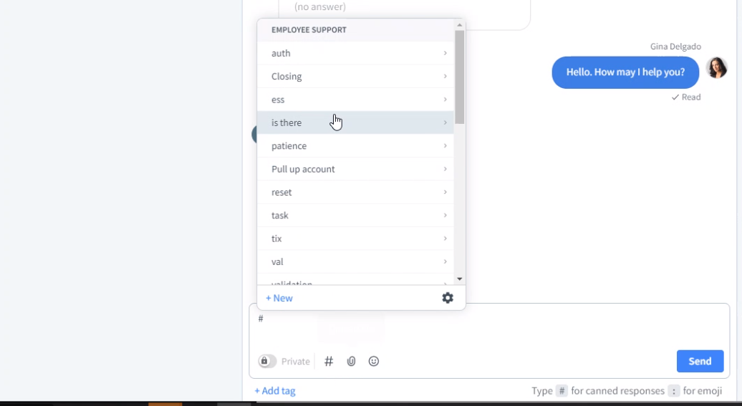

  - Details
In this area we will find the information of the people that are chatting with us, their location, previous chats. Visited page, IP addresses Etc.

Important Notes:
*We must validate the Employee’s identity before accepting attachments in the chat.
*Validate the chat only if needed, if the employee is asking for general information you can assist.
*We only assist chat for employee support, they are labeled on top so that you can recognize where are they being sent to.
*Employees can rate you and all chat get saves. For Quality purposes.
*For rude employees, go to your leaders for the best resolution.

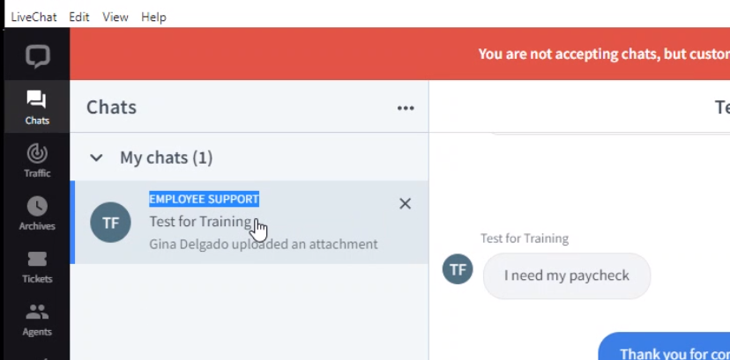

Managing chats
Supervising chats – Transferring chats

Click on the three dots on top of the chat and the system will bring the options
Supervisor:
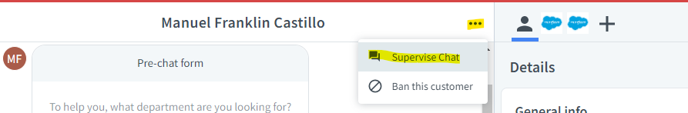
Transfer:
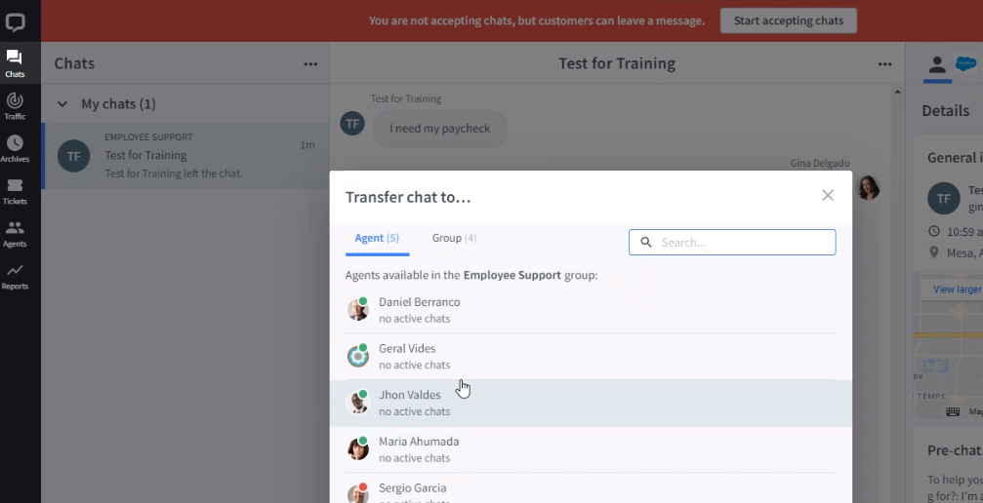
Note: Use this when required to, we should not be transferring or monitoring chats without leadership authorization.
Re-activating chats.
We can reactivate a chat if needed, just click on the open chat button and it will open the chat window for the employee to continue the communication
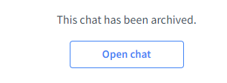

2. Traffic
Here we have all the people that are surfing on the web/ chatting with associates.

The main use of this section is to see if we have chats that are not being assisted, we can pick them up and assist. Also, will help us to review who is busy on a chat so we can ask for help to other teammates.
Note:
Do not supervise or pick chats without leadership authorization.

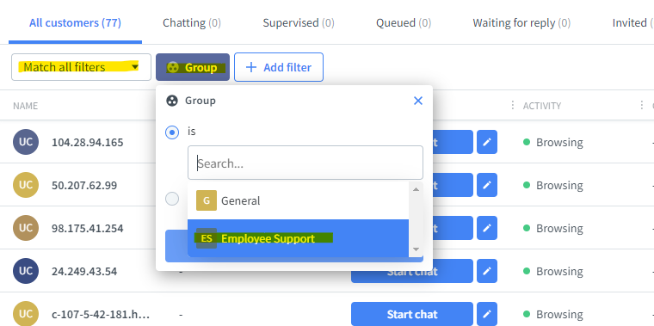

We can also save this segment setting if we need to:
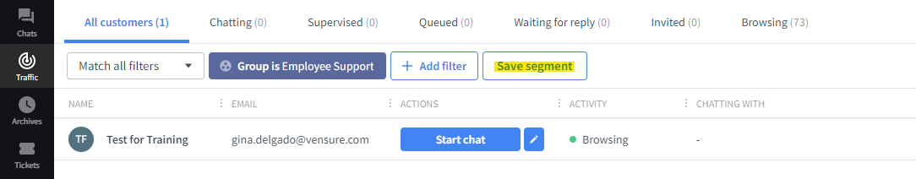

Supervisor role
Here we will be able to see in live action how a chat is being handled. If we need to step into the assistance we can do so, by texting the associate privately, this way we will provide support or corrections when needed.
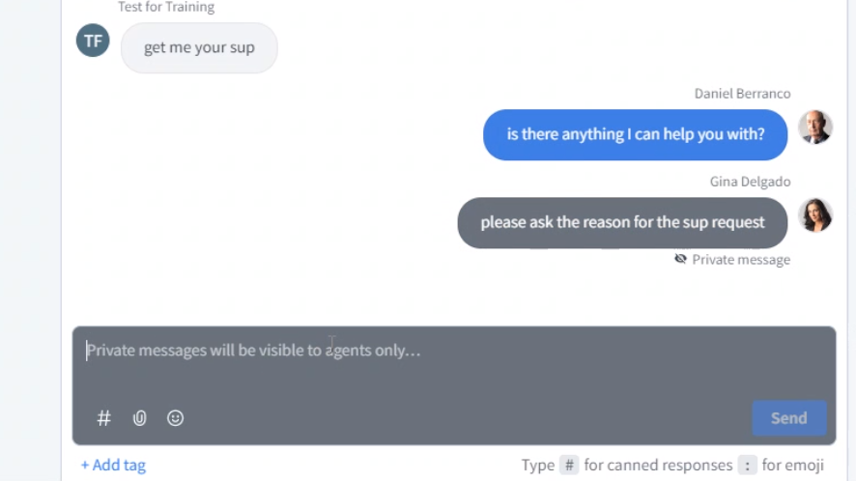
Note: Associates cannot reply to supervisors. Be careful with this.

3. Archives
This is where all the chats history gets stored, if you want to review information from previous chats, this is the place to go.

Note:
Use this for information purposes, we should not reactivate previous chats.

Settings:
Is important that we have the same settings for each associate, please check the following images with the standard settings for associates.
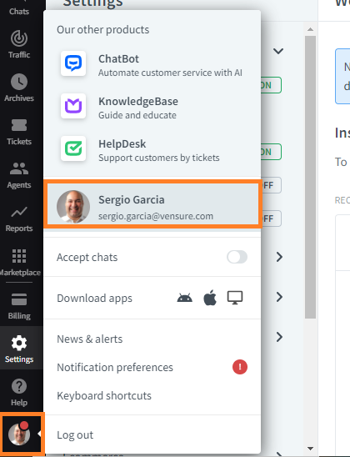
To access your personal settings, click on you profile picture and click on your name.
Note: Please use the pictures we have in the system by default we are not to upload our personal picture, this is the set up of the Status after logging in item:
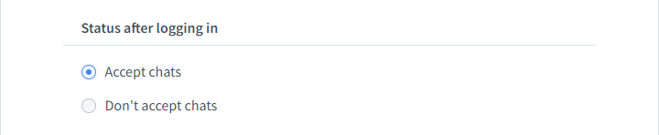
Notification’s preferences
This is how your settings should look like:
