Timeco

Employee Guide

Contents
Accessing Timeco in Employee Web Portal 3
Add Punch Widget 4
My Leave Request Widget 4
My Dashboard: 6
My Schedule: 6
My Timecard: 7
My Leave Request: 8
Time-Off Request in Prism 10
My Leave Request in Timeco 11
My Leave Request: 11
Timeco Employee Entering Expenses 14

Accessing Timeco in Employee Web Portal

To Access Timeco within EmPower HR Employee Web Portal
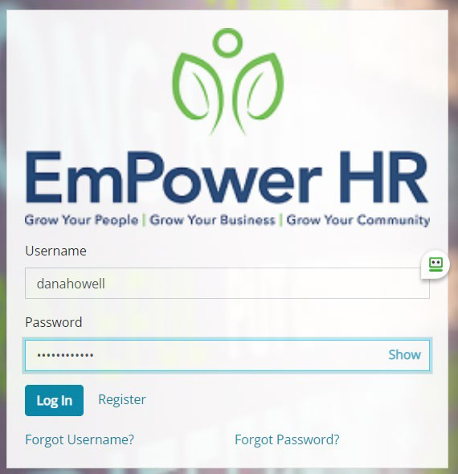
- Login into your Empower HR Employee Web Portal:
https://epw.prismhr.com/epw/auth/#/login?lang=en

On your Employee Home Dashboard there will be two widgets that are available to you:
- Add Punch
- My Leave Request (Based on your company’s leave policies)
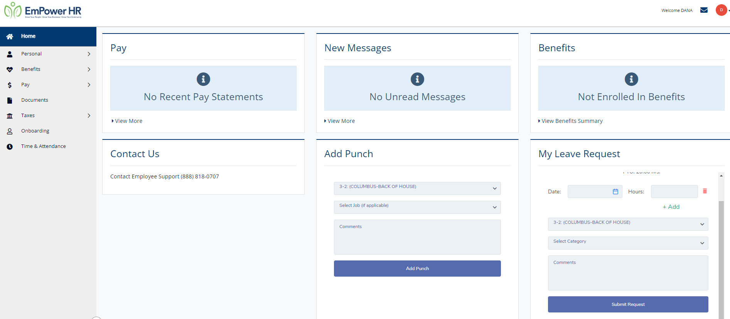
These widgets will allow you to punch in and out as needed along with allowing you to request time off based on your company’s leave policies.

Add Punch Widget
Employees can punch in/out by selecting the Add Punch button. If your company has selected to allow you to switch between different Job segments, additional drop downs will be available.
Job Segments may be set by Department, Division, Position and Job if applicable. Additionally, employees may leave a comment to be viewed by their supervisor.
Employees that work in multiple “Work Segments” throughout the day, may transfer/move from Department, Division, Position or Projects as required. Please note, the work segments may differ, depending on the company setup.
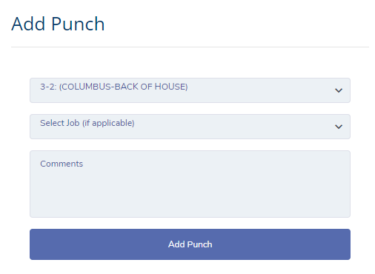

My Leave Request Widget
On the Leave Request Widget, employees can review available hours to use for their time off requests. Time off requests will be sent to their supervisor or other assigned company employee to review for approval. Employees will receive notice to the email registered in their EmPower HR Employee Portal user.
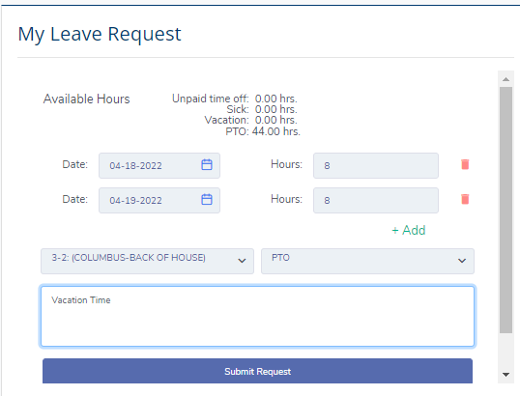
Employees may request one or more days off by entering the date(s), hours, and type of leave. Once all required fields are complete click the Submit Request button to send your leave request.

Accessing TIMECO system from the Time & Attendance Link
From the EmPower HR Employee Portal menu, select the Time & Attendance link to open the Timeco system for additional access and information.
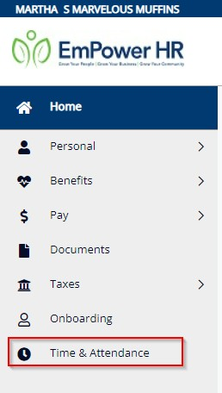
Access the Employee Service Menu by selecting the Head Icon in the upper right corner.
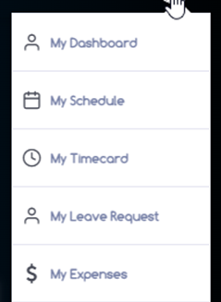

My Dashboard:
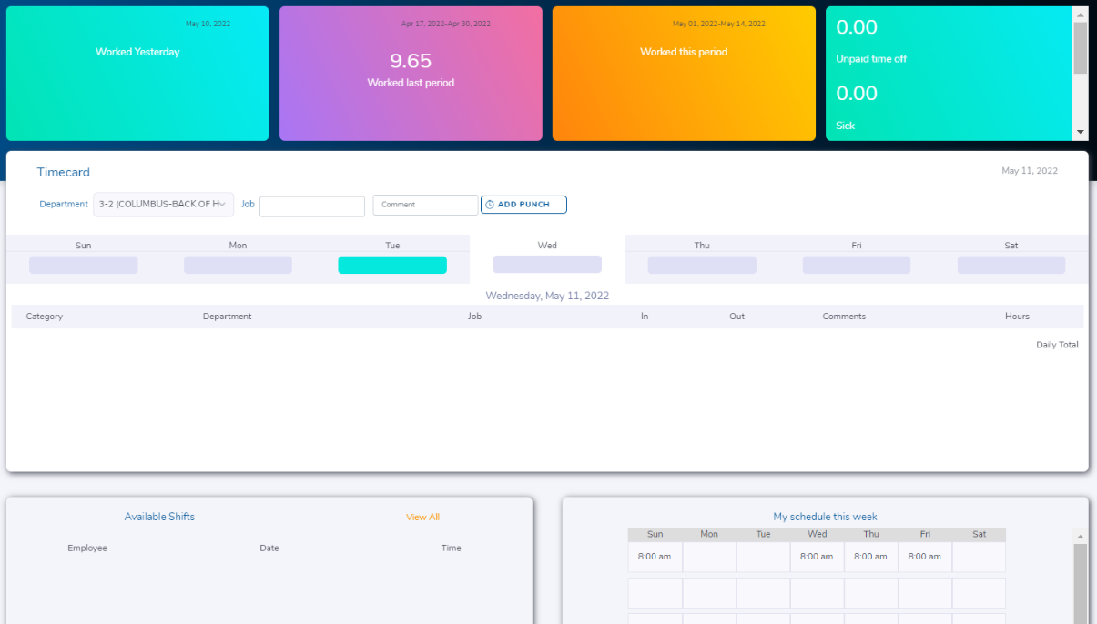
The employee Dashboard will show various metrics for the current week, along with the Time off balances for policies used by your company such as PTO/Vacation/Sick balances. Employees can also view available shifts and work schedules, if applicable.

My Schedule:
Employees can view their schedules by week or month. Additionally, employees may be able to request a shift or add their availability to work days and hours. Company policies will manage the settings and users access. My Schedule may not be set up to be used by your company.
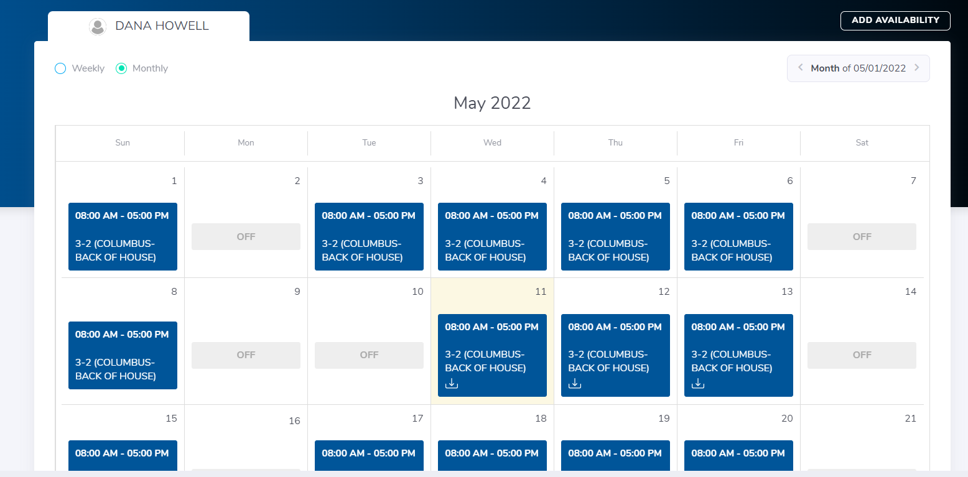

My Timecard:
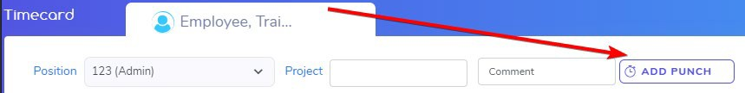
To punch in or out, select the Add Punch button and the current time will be added to the timecard.
An employee may also enter some comments in the comments box along with the punch. The employee’s supervisor will see these comments when approving the timecard.
If an employee works in various “Work Segments” throughout the day, they may change the Position or Project fields as seen below.
Please note, the names of the segments will change, depending on the company setup. For example, an employee may see Location, Department, Job, Division, etc.
*Important Note* – if an employee is already punched in for the day, changing the Segment will clock them out and back in. There is no need to punch out first. By changing the work segment, an employee will effectively ‘move’ to the alternate work area:
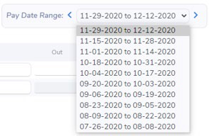
An employee may review their punch history by clicking the Pay Date Range at the top right of the timecard:
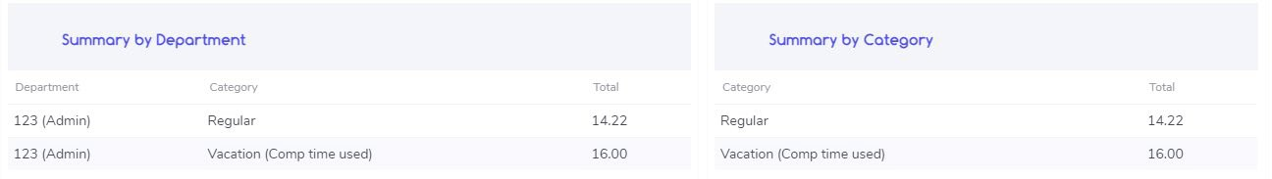
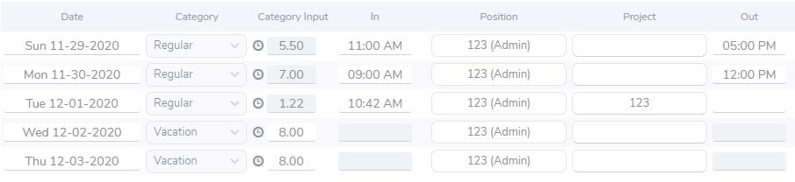
The timecard will display the punches for the current pay period with a grand total at the bottom:
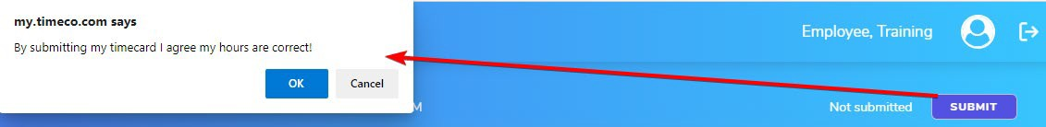
An employee may click Submit and sign the timecard digitally. By submitting the timecard, the employee is agreeing that it is accurate and correct to the best of their knowledge at this date and time.

My Leave Request:
The My Leave Request area allows the employee to review current, future, and previous time-off requests. Also, view available hours and add a new leave request.
Available Hours – allows an employee to view their current balance as of last payroll posting.
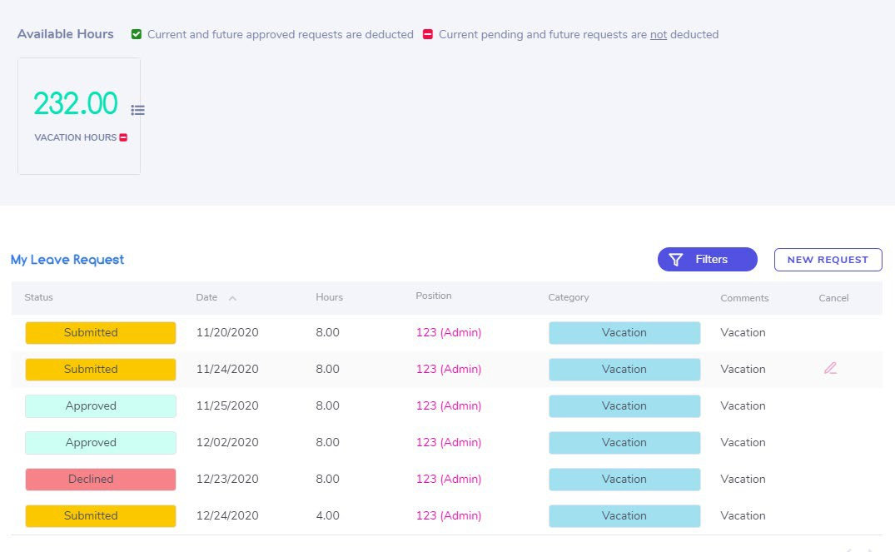
New Request Time Off – click the New Request button at the top right of the Leave Request area to submit a new request.
- Choose the Leave Request Type for Vacation, PTO, Sick, etc. Available options are set based on company policies.
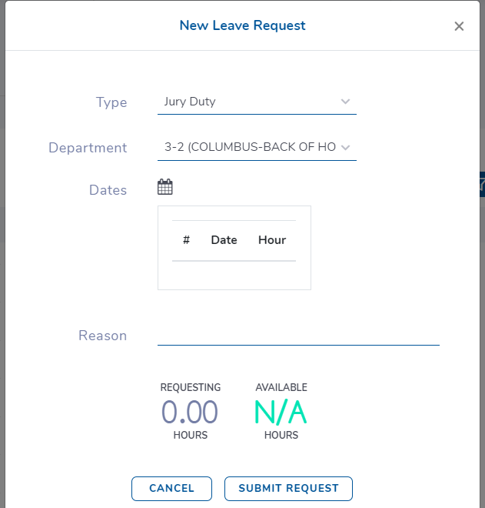
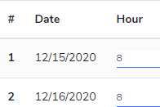
- Enter the dates by Selecting the calendar icon then selecting the days via the calendar popup. Add the hours for each day
Select Submit Request button to send request to the supervisor(s) for approval.
Cancel Leave Request--An employee may cancel their request if the request remains submitted (unapproved) or even if the request was approved already. To cancel a request, select requested date, and click the Cancel icon () in the right column. 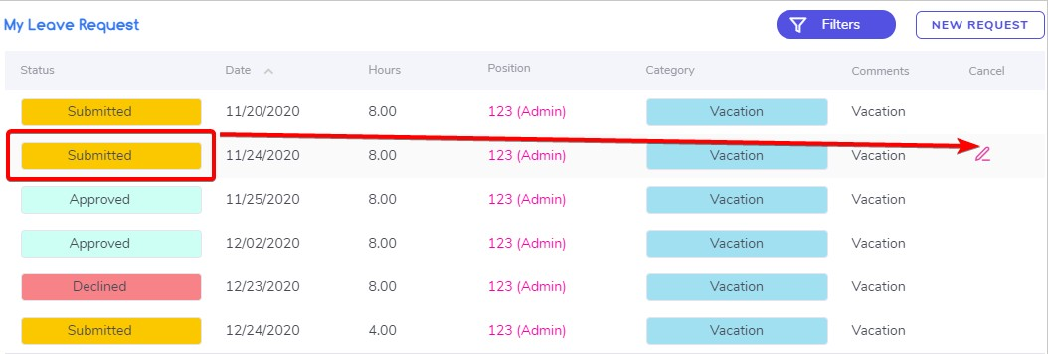
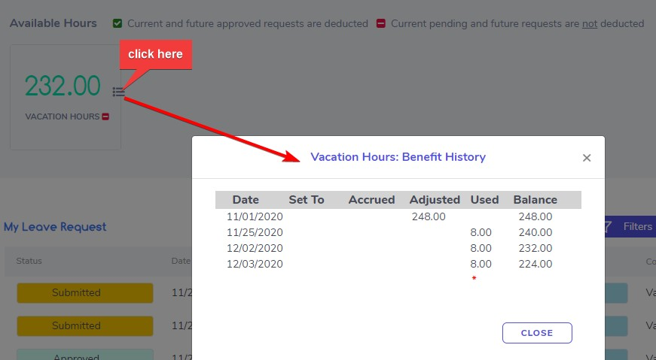
History Menu-- click the small calendar icon to review the history associated with this leave request category. Note: For accrual based plans, balances will be adjusted on each pay date.

Time-Off Request in Prism
Employees can request leave by logging into their Prism Employee Portal. After you have logged in you will see the TimeCo Leave Request widget on your dashboard in the bottom right corner.
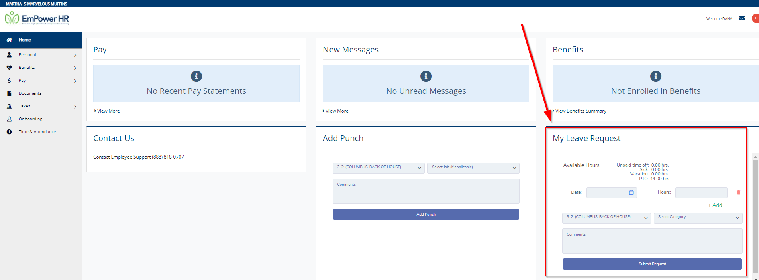
You can request one or more days by entered the date(s) you are requesting off, hours and type of leave. These request(s) will be assigned to your supervisor for approval or denial within Timeco.
Once you have entered in your request, click the Submit Request button to complete your leave request.

My Leave Request in Timeco

My Leave Request:
This section allows an employee to review and submit time off requests.

Available Hours – allows an employee to view their current balance (as of this very moment) and click the small calendar icon to review the history associated with this leave request category:
The My Leave Request area allows the employee to review current, future, and previous time-off requests.
An employee may cancel their request if the request remains submitted (unapproved) or even if the request was approved already. To cancel a request, select requested date, and click the Cancel icon () in the right column.

New Request – click the button at the top right of the main leave request area to submit a new request.
- Choose the Leave Request Type for Vacation, PTO, Sick, etc. This depends on the options available to the employee.
- Select the calendar icon then select the days via the calendar popup.
- Ensure the proper hours are entered per day in the form:
- Select at the bottom of the form, and the request will be emailed to the supervisor(s) for approval.

- The employee may track this request from the My Leave Request area, and they will also be notified by email once the request is approved/declined.
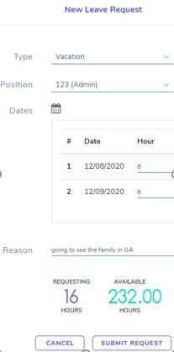

Timeco Employee Entering Expenses
Employees that have access to enter expenses into the timecard (based on Role of the user) can navigate to the “My Expenses” area of the menu to the right of their name:
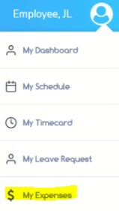
Click the “Add Expense” button at the top right, then the expense sheet can be completed, per the expense details.
Optionally, a file can be uploaded and attached to the expense form. For example, a receipt for gas.
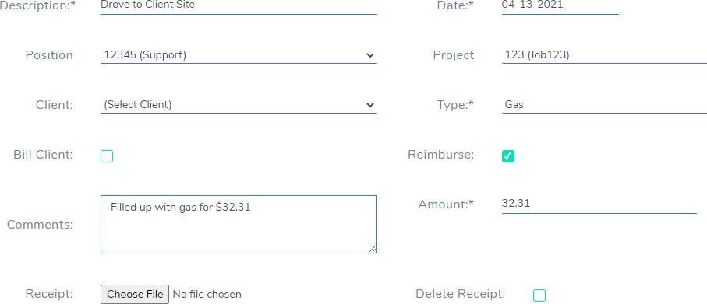
If using the mobile version of the Expense Sheet, the Employee’s camera on their phone can be utilized to upload/attach the image (use camera to take a photo of the receipt, then the Choose File button to navigate to the image on the device)

